**FACE DETECTION APP SCREENSHOTS**

**By CHINTA RAKESH.**

**1)AWS LOGIN WITH USER NAME:**

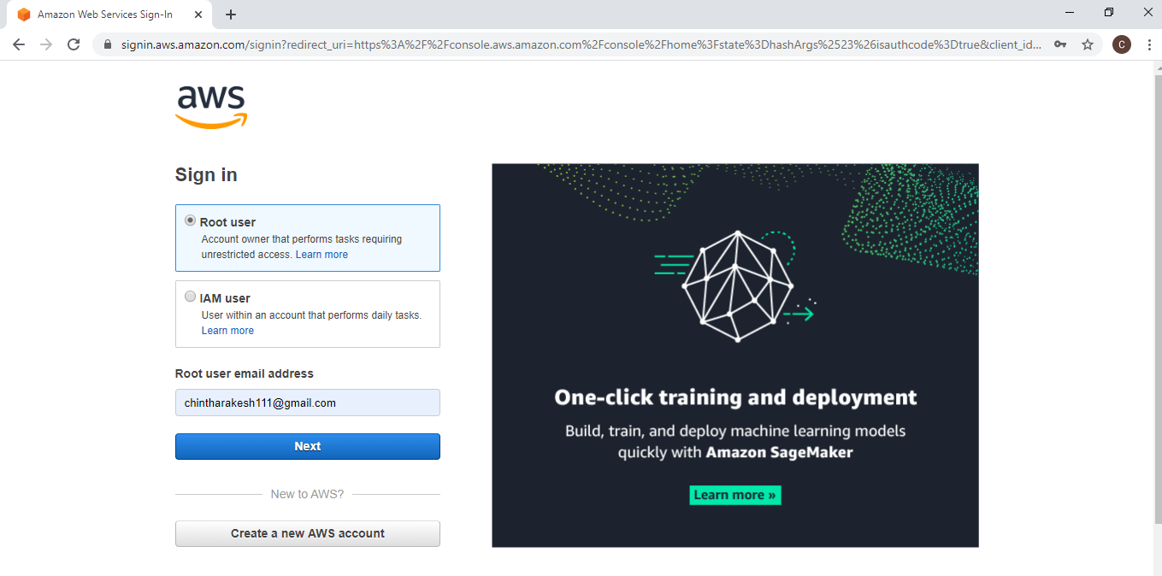

**2)EC2 DASHBOARD:**

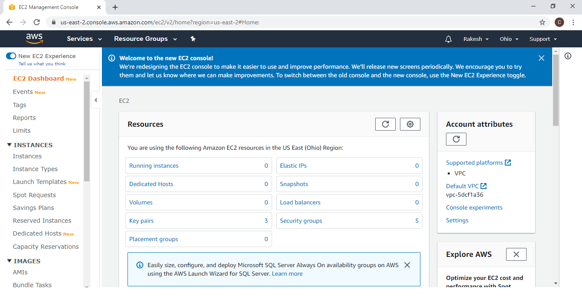

**3)S3 DASHBOARD:**

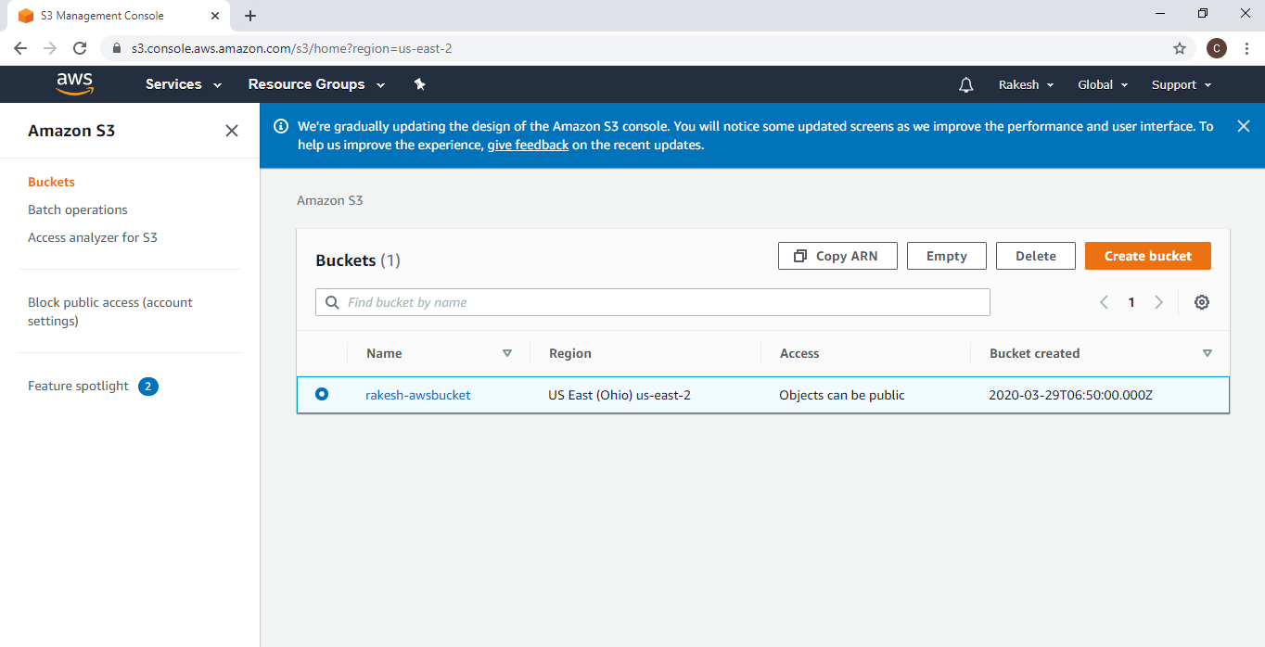

**4)REKOGNITION DASHBOARD:**

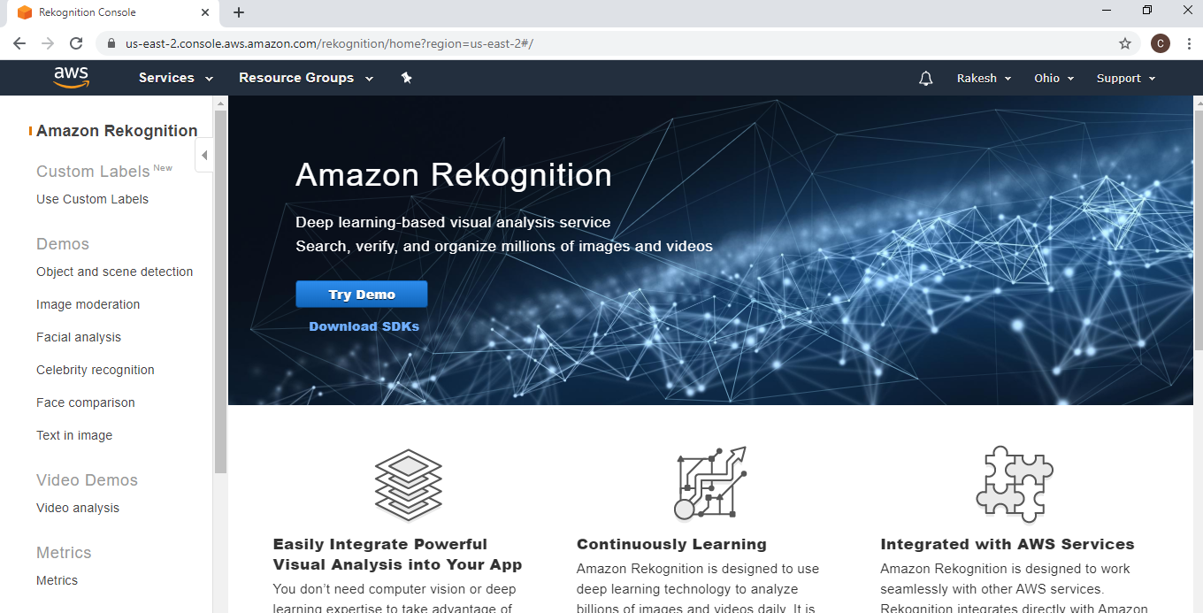

**5)CHOOSING AN AMI IN EC2:**

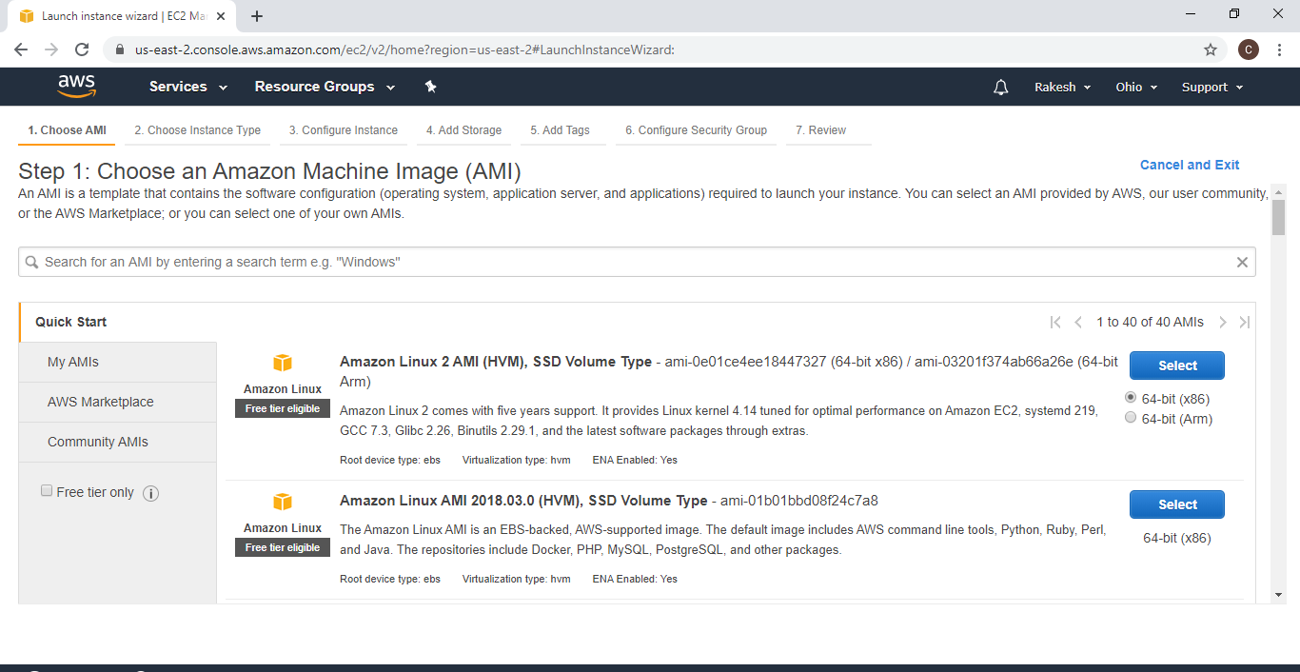

**6)CHOOSING AN INSTANCE TYPE IN EC2:**

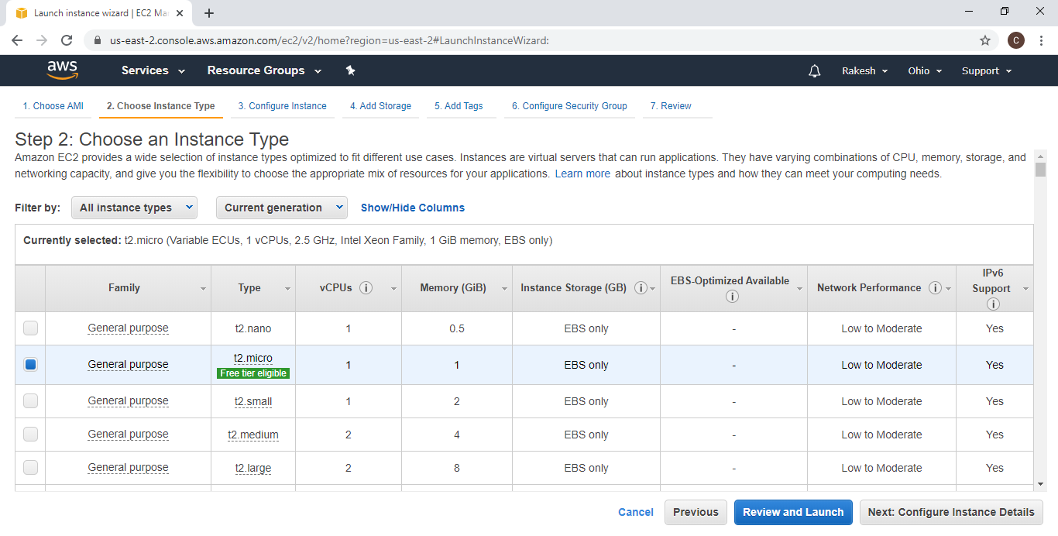

**7)ADDING STORAGE IN EC2:**

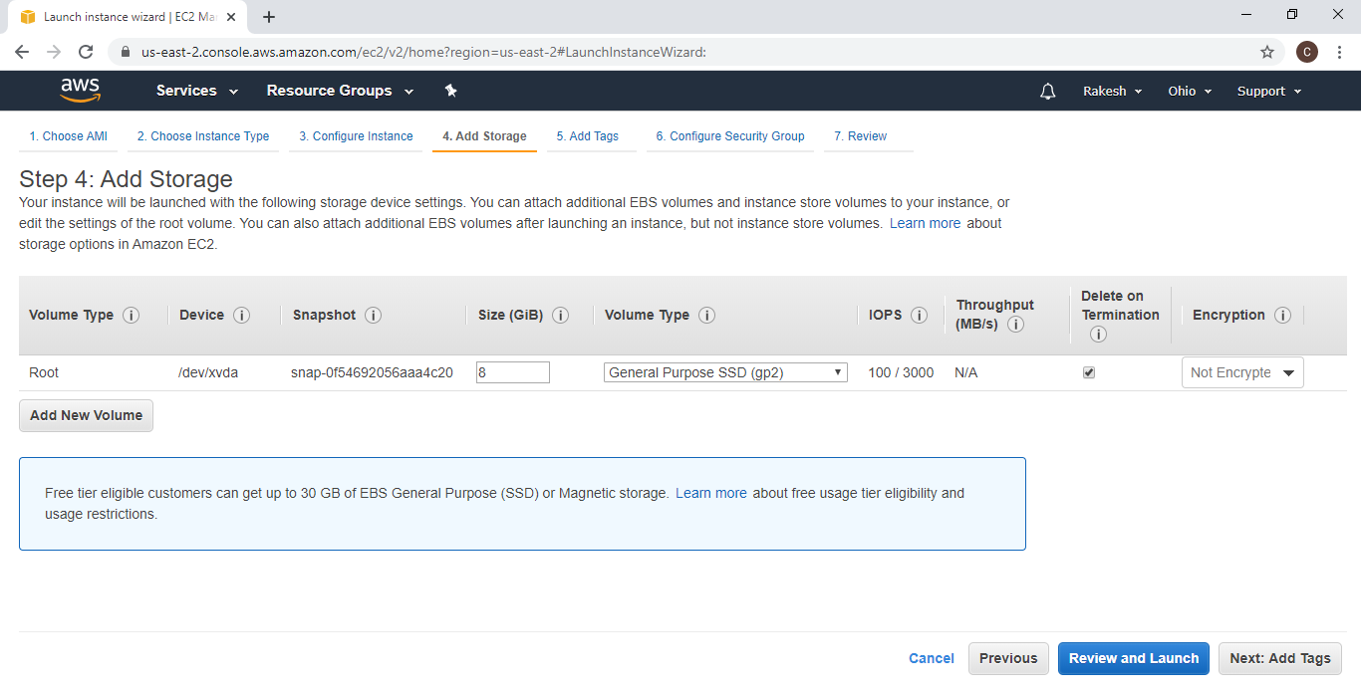

**8)CONFIGURING SECURITY GROUP IN EC2:**

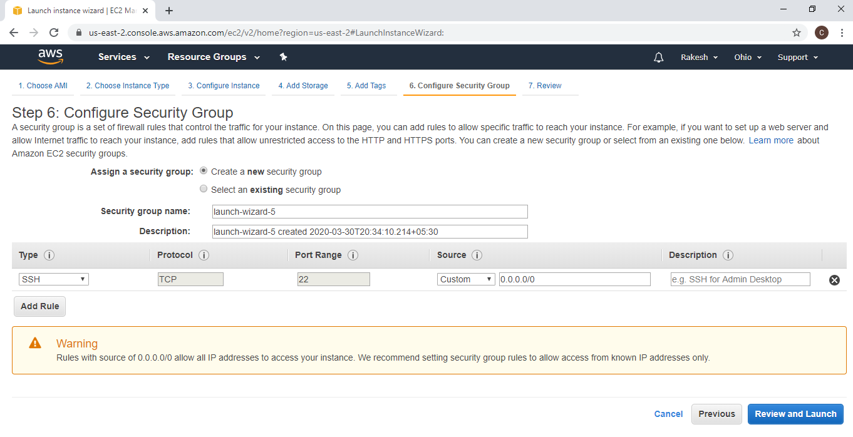

**9)KEY PAIR DOWNLOAD IN EC2:**

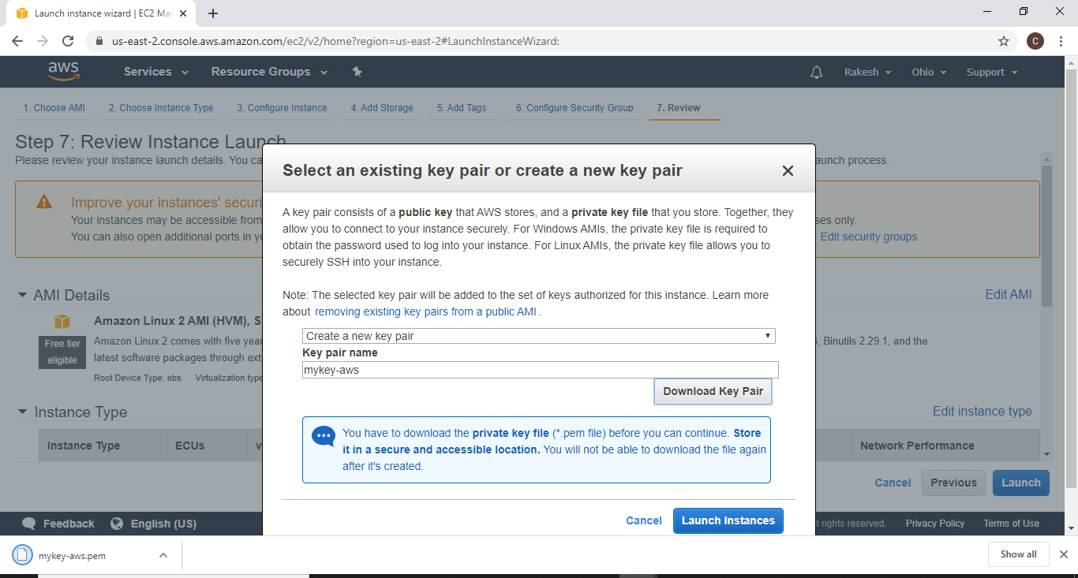

**10)PUTTYGEN CONVERSION FROM PEM TO PPK:**

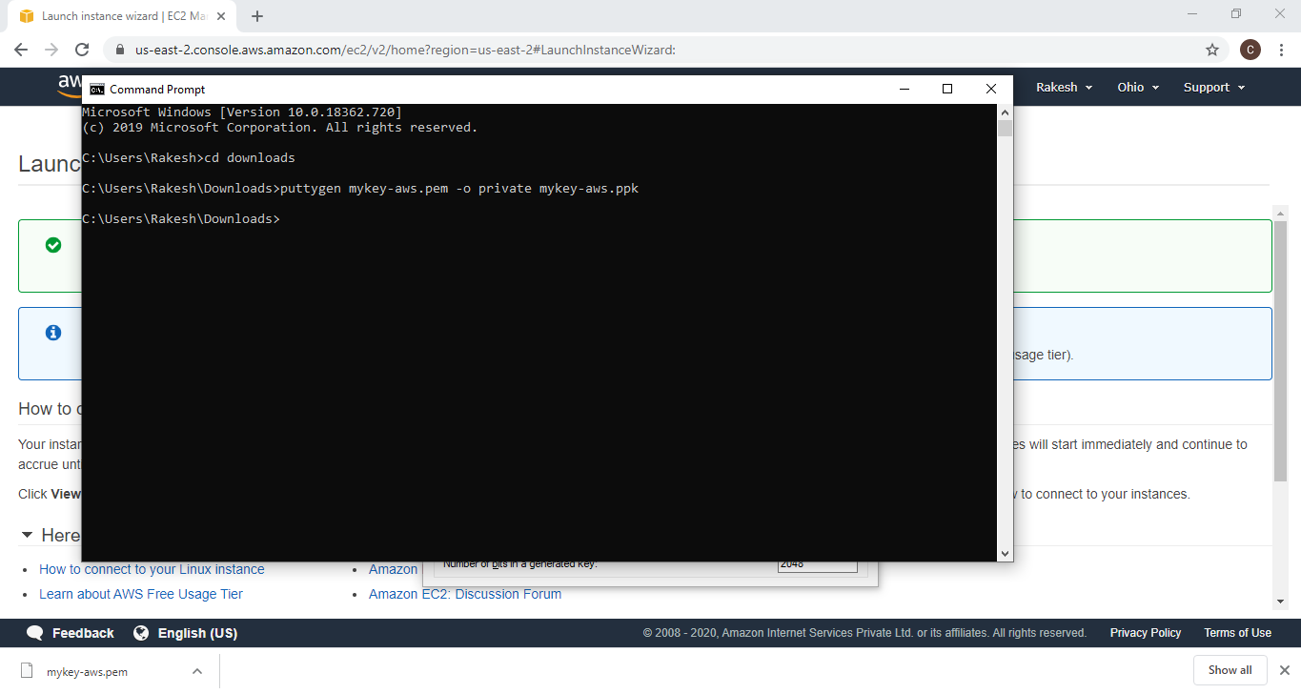

**11)LOGGED IN EC2 USING PUTTY:**

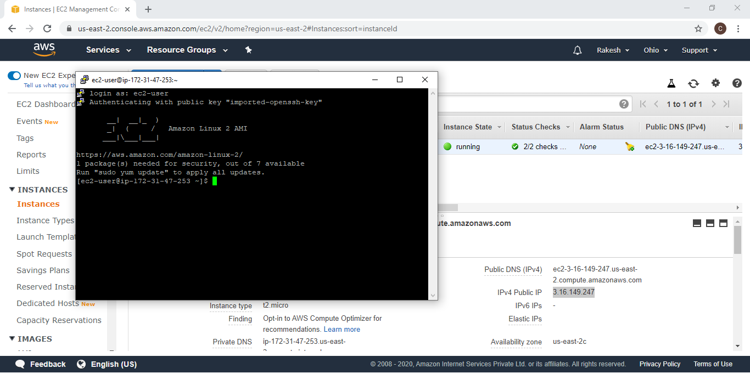

**12)CREATING A BUCKET IN S3:**

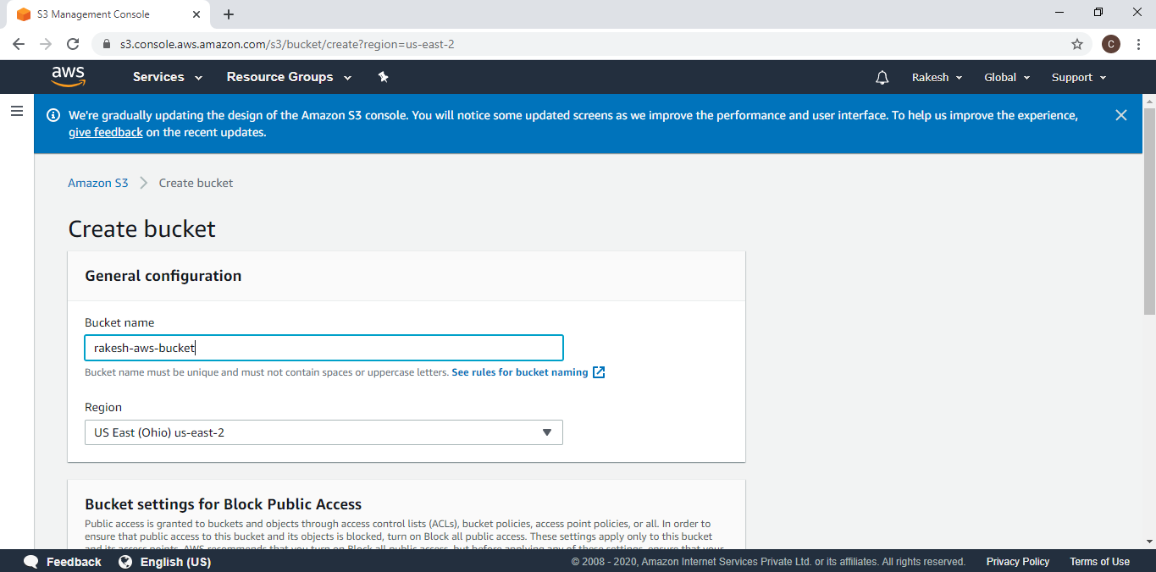

**13)UPLOADING AN OBJECT IN BUCKET IN S3:**

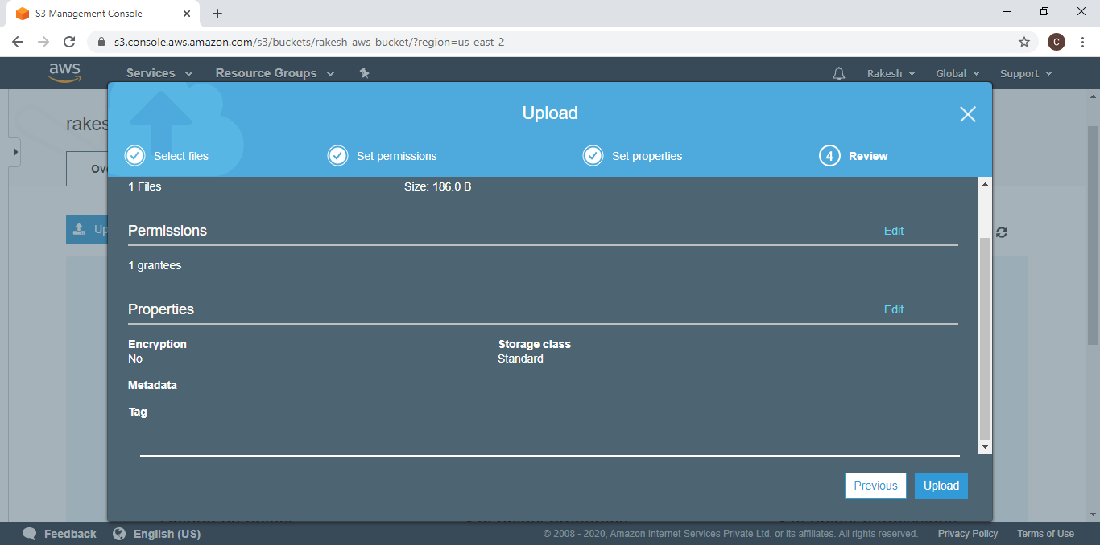

**14)ENABLING STATIC WEBSITE IN S3:**

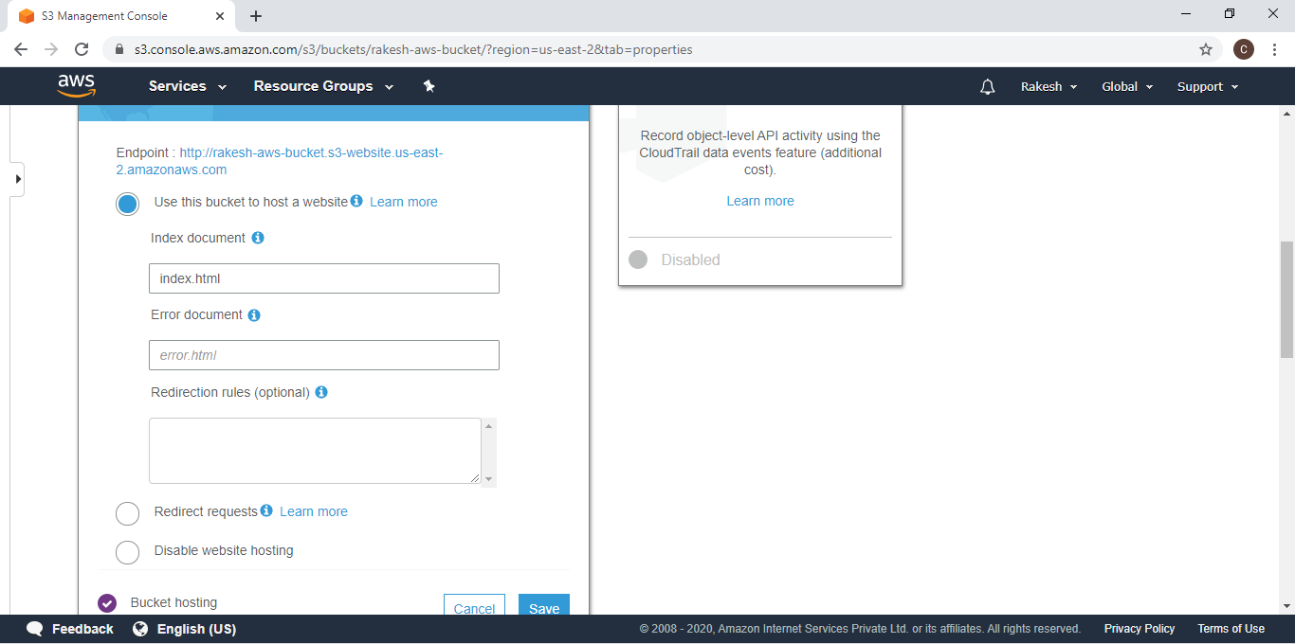

**15)MAKING AN OBJECT PUBLIC IN S3:**

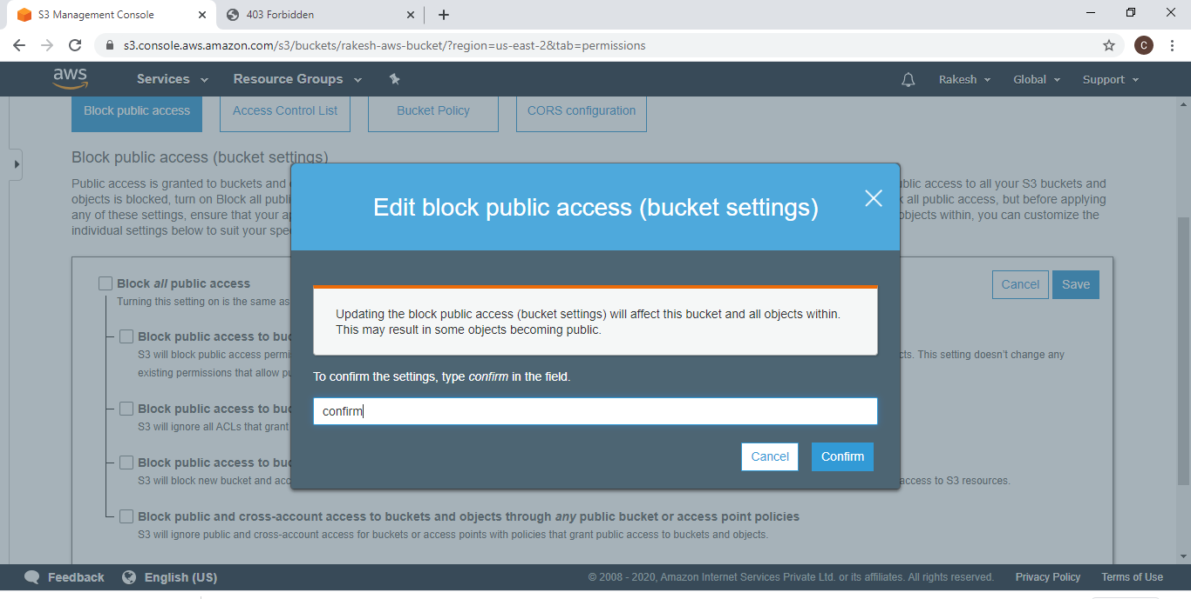

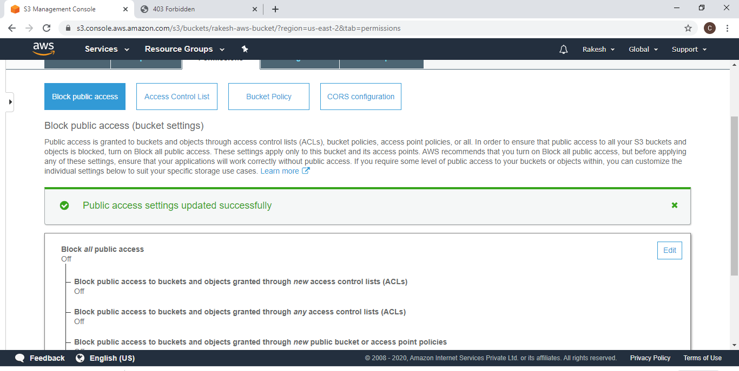

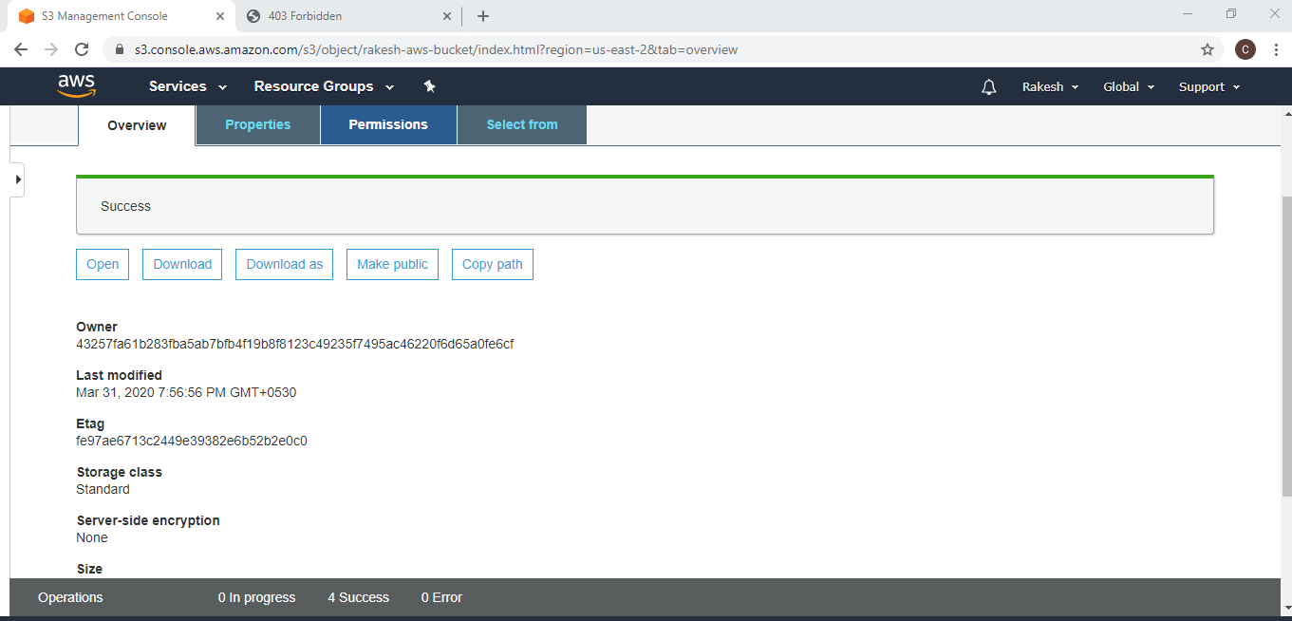

**16)CHECKING THE S3 LINK ON THE BROWSER:**

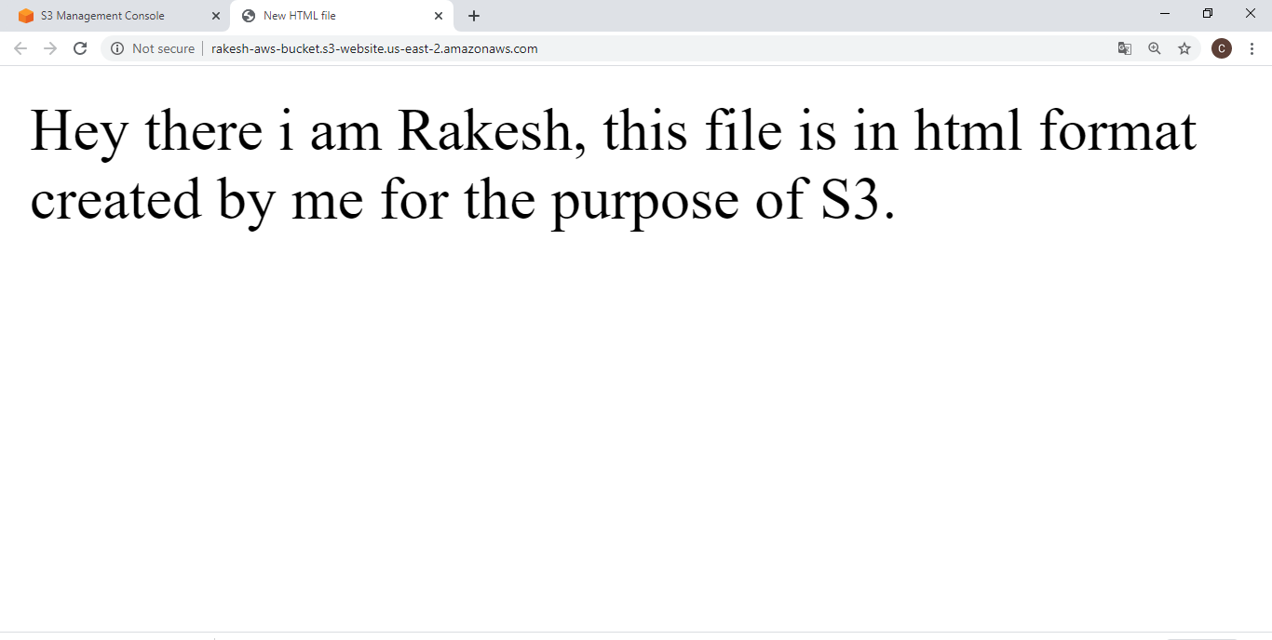

**17)FACE DETECTION IN REKOGNITION:**

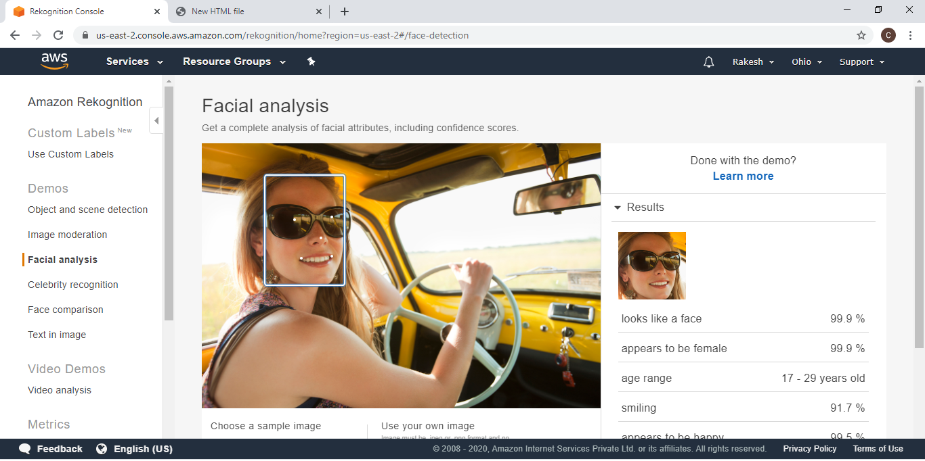

**18)FACE COMPARE IN REKOGNITION:**

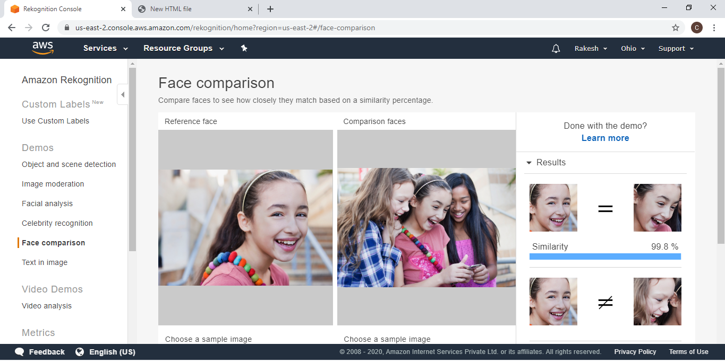

**19)CELEBRITY RECOGNITION IN REKOGNITION:**

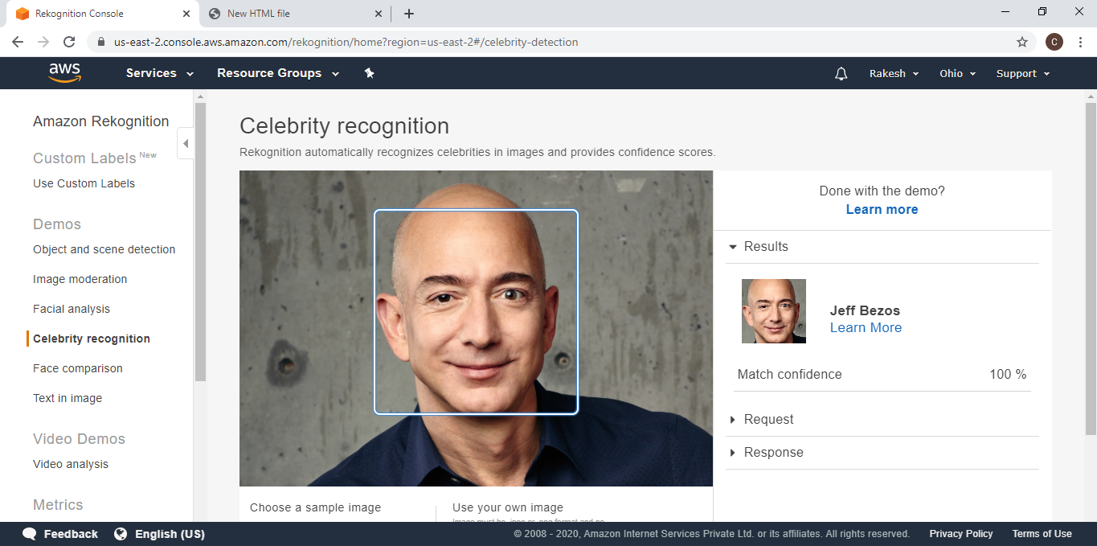

**20)TEXT IN IMAGE IN RECOGNITION:**

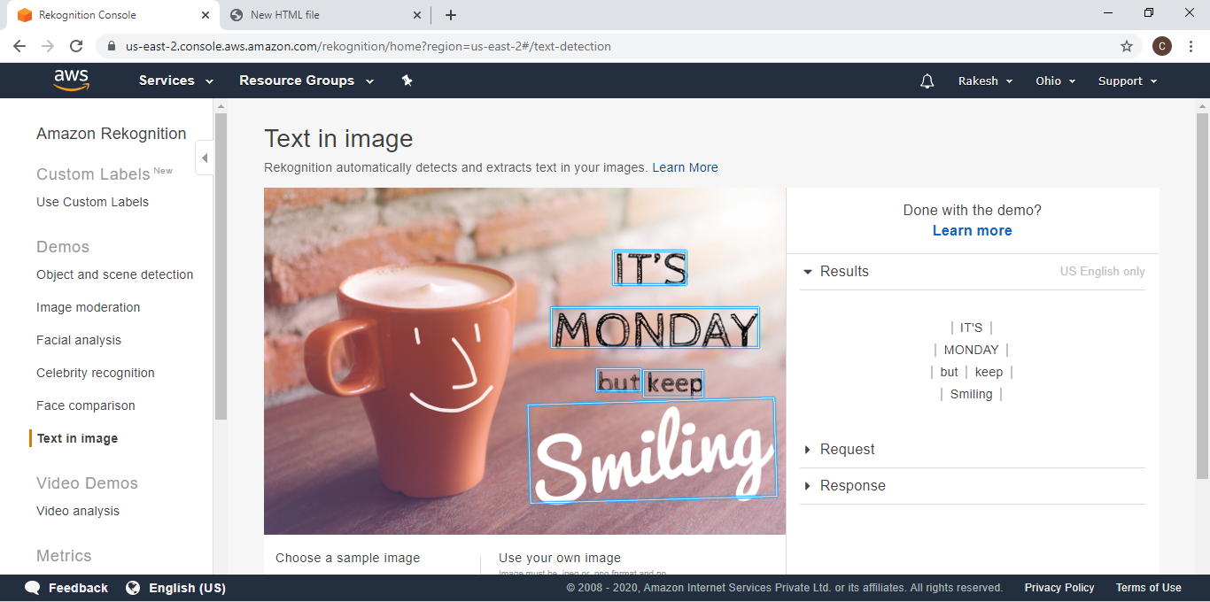

**21)INSTALLING AWS-SDK:**

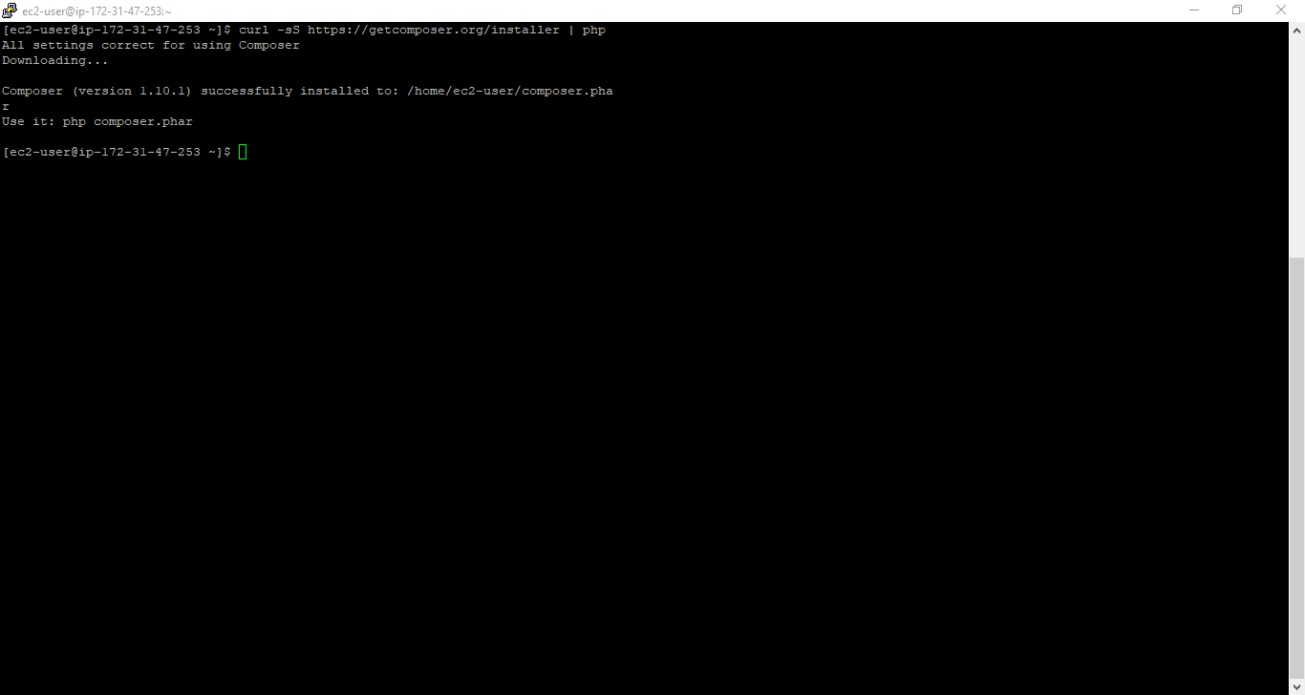

**22)INSTALLING PHP:**

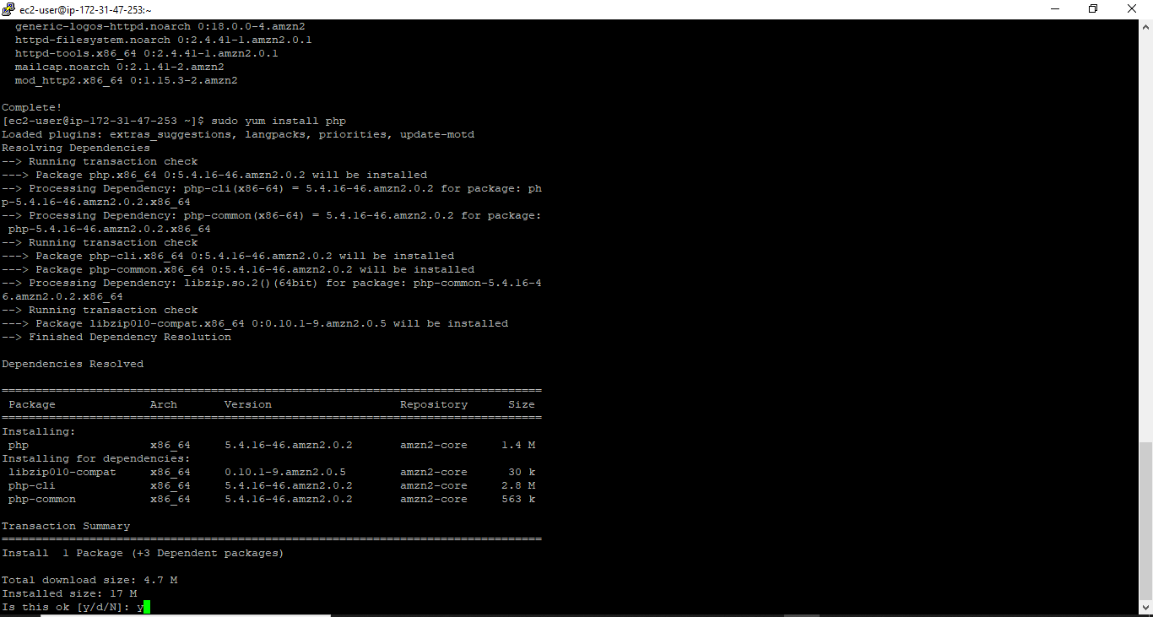

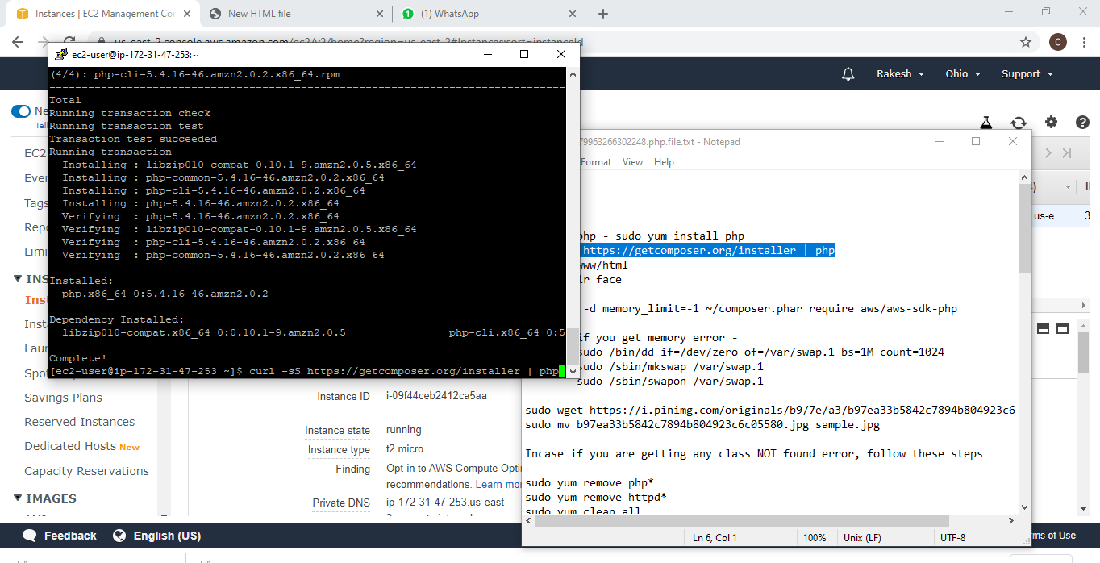

**23)INDEX.PHP CODE:**

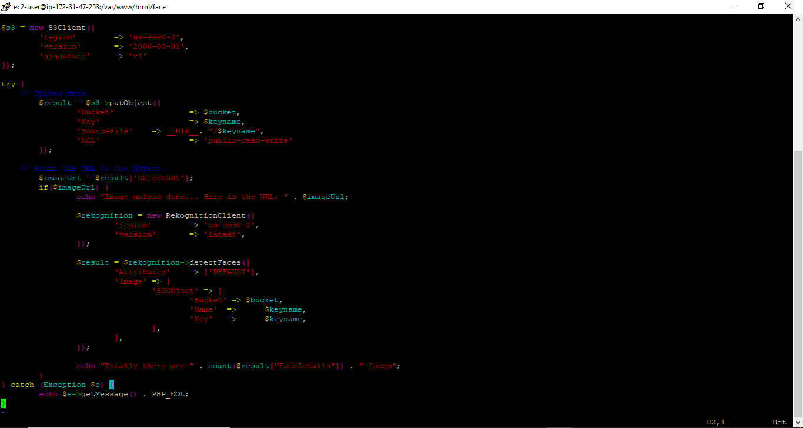



**24)UPLOAD SUCCESS SCREENSHOT:**

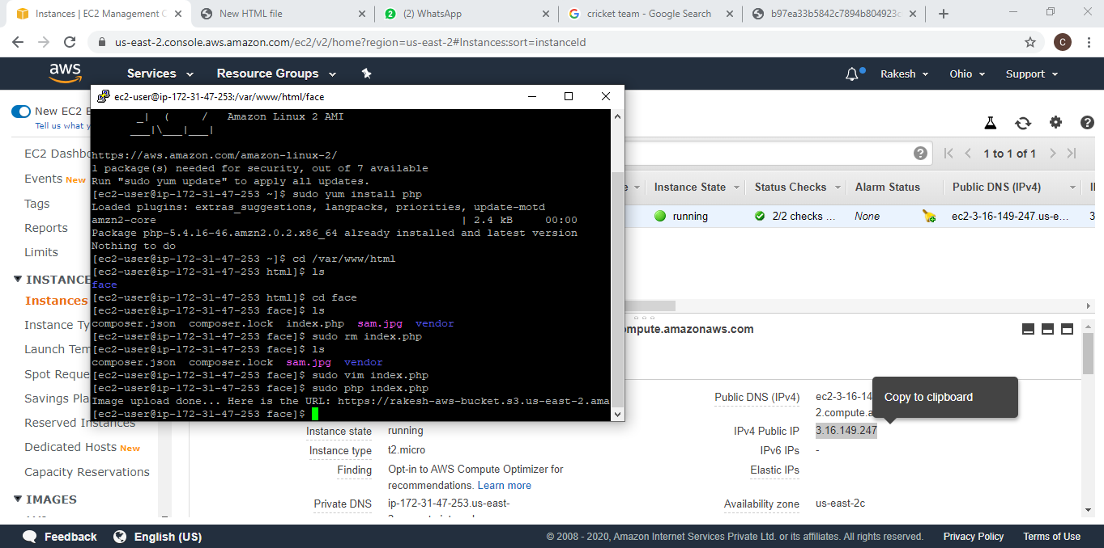

**25)FACE DETECT SUCCESS SCREENSHOT:**

